**Bioinformatics Report**

**Module 5**

4624650

Anna Paula Pawlicka Maule

**Exercise 1:**

*In this exercise will be computed the distances of the sequences of mitochondrial DNA from the mammoth, African elephant and the Asian elephant. The identifiers of these sequences are in GenBank: NC_007596, NC_000934, NC_005129 respectively.*

*Before computing the distance between these sequences, you should first remove the control region (D-loop) and then to the global alignment thereof. Following these steps are described:*

*A) Only the following nucleotides should be KEPT in the sequences:*

*Mammoth: 1 to 15421*

*African elephant: 1 to 15417*

*Asian elephant: 1 to 15419*

*B) Perform the global alignment of the remaining sequences using the Clustal OMEGA.*

*C) To analyze the distances of DNA sequences from the Percent Identity Matrix created by the Clustal OMEGA*

**Answer:**

In order to complete this exercise, I created a python [Script](https://github.com/ICMC/Computation-Biology/blob/master/modulo5/GetSpecificPartsOfThegene.py) to remove the D-loop region. After running the global alignment at [Clustal Omega](https://www.ebi.ac.uk/Tools/msa/clustalo/) , the percent identity matrix was the following:

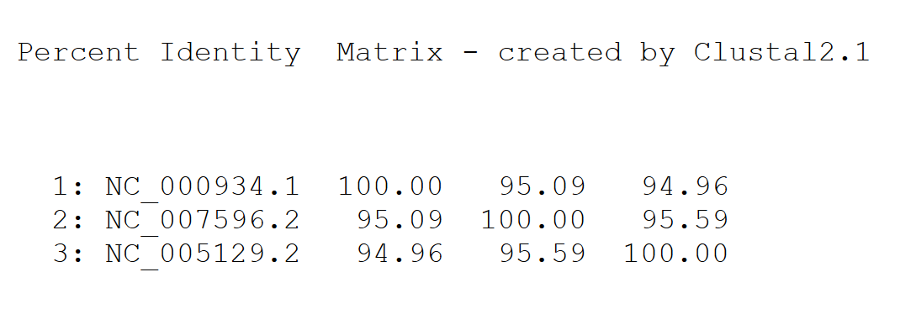

Analyzing the matrix it is possible to observe that the Mammoth, African Elephant and the Asian Elephant have a not so distant common ancestor.

**Exercise 2:**

*Do the local alignment of the 12S ribosomal RNA gene-tooth tiger saber () against the base of nucleotide collections.*

* *Enter the name of the 5 organisms whose sequences are more similar to the tiger tooth desabre gene. Provide E.Value and the Total Score for each. Do you think that these organisms have some relationship?*

**Answer:**

Follows the results of the local alignment of the gene-tooth tiger saber obtained by using the [Blastn Tool](https://blast.ncbi.nlm.nih.gov/Blast.cgi?PAGE_TYPE=BlastSearch) :

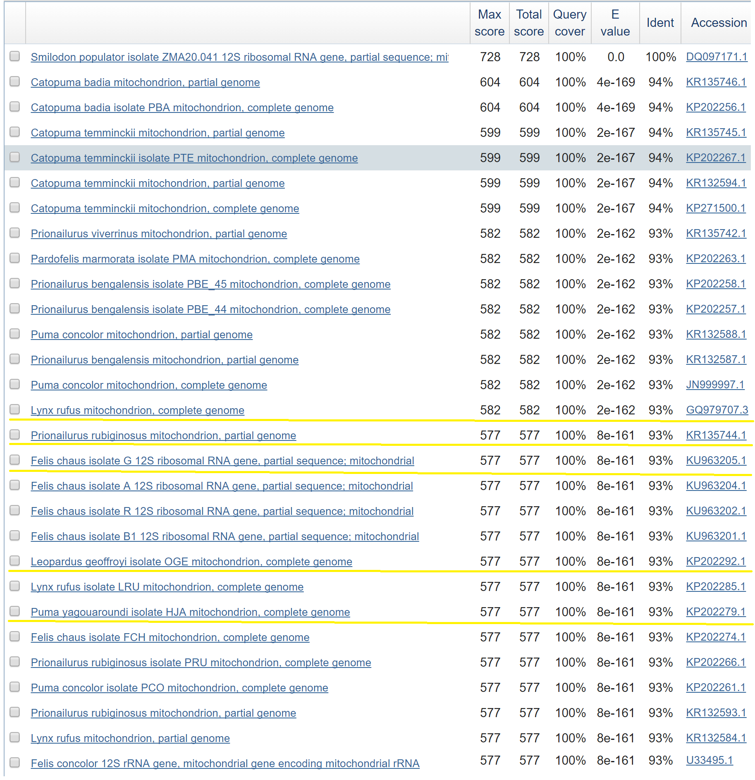

Among all the similar organism I chose 5 that their names are more familiar to me. It is possible to affirm that all those organism belong to the same group, they are feline. The 5 I choose they have the same max score and E values, which means they are ancestors of the tiger saber and that they all migrated to the same region and kept their mitochondrial genes more similar among that group. If you observe other organisms in this table, I is possible to notice that are other ancestors groups with higher similarity to the tiger saber. Which could mean those organisms migrated far less than the others and also they could be much older feline races.

**Exercise 3:**  *The mitocondial DNA sequences of the blue whale, hippo and cow are respectively NC_001601, NC_000889 and. The blue whale is genetically closer to the cow or hippo?*

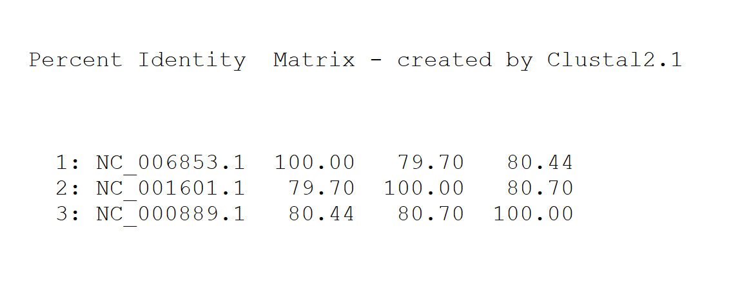

**Answer:**

According to [Clustal Omega](https://www.ebi.ac.uk/Tools/msa/clustalo/) global alignment percent percent identity matrix the whale is closer to the hippo. They had a better alignment between them.